|  |
| --- |
|  |
| Homework #4 – University Accommodation |
| CS 488 – Database Management |
|  |
| **Eric Whatley, Aaron Rudolph** |
| **4/3/2014** |

|  |
| --- |
|  |

Table of Contents

Description of Scenario 2

Case Scenario 2

Business Logic 2

Business Constraints 3

Functional Dependency Analysis 4

Student 4

Hall 4

Lease 4

Room 4

Inspection 4

Staff 5

Entity Relationship Diagram (ERD) 6

Data Dictionary 7

Student 7

Hall 8

Lease 9

Room 10

Inspection 11

StaffHW4 12

Sample Data 13

Student 13

Hall 16

Lease 16

Room 17

Inspection 17

StaffHW4 18

Query Source Code and Outputs 20

(c) 20

(f) 20

(i) 21

(l) 21

(n) 22

# Description of Scenario

## Case Scenario

The directory of the University Accommodation office came to us with a request to design a database to help with the administration of the office. The requirement collection and the analysis had already been provided to us along with some sample query transactions the database should be able to complete. We picked these five different relations to design based on the analysis: Student, Hall, Lease, Inspection, Staff.

## Business Logic

**Students**

Students are to have a student number, name (first and last), address, phone number, email, date of birth, gender, category, nationality, special needs, comments, status, major, and minor specified in the database. Minor, comments, special needs, nationality, and email are not required.

**Halls**

Halls are to have a hall number, name, address, phone number, and manager number. All attributes are required, and manager number refers to a staff member.

**Lease**

Leases are to have a lease number, duration, semester, place number, and student number. All attributes are required. Place number refers to a specific room in a specific hall. Student number refers to a specific student.

**Room**

Rooms are to have a place number, hall number, room number, and rate. All attributes are required. Place number is simply the hall number composed with the room number to uniquely identify the room.

**Inspection**

Inspections have a staff member that inspects the room, the place number, the date, whether it was satisfactory, and comments. Comments are not required. Staff number, place number, and date uniquely identify an inspection.

**Staff**

Staff has a staff number, name (first and last), address, phone number, email, date of birth, gender, position, and location. Only the email is not required. The location can refer to the office they work in or the hall number.

## Business Constraints

**Student**

There is only one student number for each student.

**Hall**

There is only one hall number per hall.

There is only one manager per hall.

**Lease**

There is only one lease number per lease.

A student may only have one lease at a time.

**Room**

No hall may have 2 rooms with the same room number.

**Inspection**

A staff member may only inspect one room once a day.

**Staff**

There is only one staff number for each staff member.

# Functional Dependency Analysis

## Student

There is only one sNo for each student.

studentNo fName, lName, address, phone, email, dob, gender, category, nationality, specialNeeds, comments, status, major, minor

## Hall

There is only one hallNo for each hall and only one manager.

hallNo name, address, number, mgrNo

**Transitive dependency:**

hallNo mgrNo fName, lName, address, phone, email, dob, gender, position, location

## Lease

There is only one leaseNo per lease.

leaseNo duration, semester, placeNo, studentNo

**Transitive dependencies:**

leaseNo placeNo rate

leaseNo studentNo fName, lName, address, phone, email, dob, gender, category, nationality, specialNeeds, comments, status, major, minor

## Room

placeNo hallNo, roomNo, rate

## Inspection

A staff member may only inspect a room once a day.

(staffNo, placeNo, date) satisfactory, comments

**Transitive dependencies:**

(staffNo, placeNo, date)staffNo fName, lName, address, phone, email, dob, gender, position, location

(staffNo, placeNo, date)placeNo hallNo, roomNo, rate

## Staff

There is only one staffNo for each staff member.

staffNo fName, lName, address, phone, email, dob, gender, position, location

# Entity Relationship Diagram (ERD)

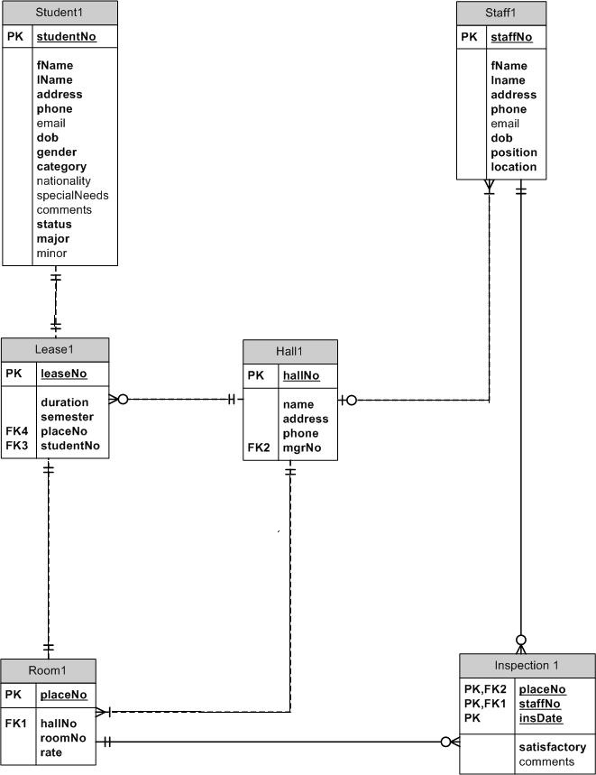

# Data Dictionary

**Student**

**Relation Schema**

Student(studentNo, fName, lName, address, phone, email, dob, gender, category, nationality, specialNeeds, comments, status, major, minor)

**Primary Key**

studentNo

**Alternate Keys**

**Foreign Key**

**Attributes**

|  |  |  |  |  |  |
| --- | --- | --- | --- | --- | --- |
| *Name* | *Description* | *Data Type and Length* | *Domain Characteristics* | *Required* | *Default Value* |
| studentNo | Uniquely identifies each student | 9 fixed characters |  | Yes |  |
| fName | First name of student | 20 variable characters |  | Yes |  |
| lName | Last name of student | 20 variable characters |  | Yes |  |
| address | Address of student | 150 variable characters |  | Yes |  |
| phone | Phone number of student | 10 fixed characters |  | Yes |  |
| email | Email of student | 30 variable characters |  | No |  |
| dob | Date of birth of student | Date |  | Yes |  |
| gender | Gender of student | 1 fixed character | Allowable values ‘M’,’m’, ‘F’ or ‘f’ | Yes |  |
| category | Category of a student (Ex: 1st year undergraduate) | 40 variable characters |  | Yes |  |
| nationality | Nationality of student | 20 variable characters |  | No |  |
| specialNeeds | Special needs of student | 50 variable characters |  | No |  |
| comments | Comments on the student | 150 variable characters |  | No |  |
| status | Status of the student (placed/waiting) | 10 variable characters | Allowable values ‘Placed’, ‘Waiting’ | Yes |  |
| major | Major of the student | 30 variable characters |  | Yes |  |
| minor | Minor of the student | 30 variable characters |  | No |  |

**Enterprise Constraints**

There is only one studentNo for each student.

**Hall**

**Relation Schema**

Halls(hallNo, name, address, phone, mgrNo)

**Primary Key**

hallNo

**Alternate Keys**

**Foreign Key**

mgrNo references Staff(empNo) on delete SET NULL

**Attributes**

|  |  |  |  |  |  |
| --- | --- | --- | --- | --- | --- |
| *Name* | *Description* | *Data Type and Length* | *Domain Characteristics* | *Required* | *Default Value* |
| hallNo | Uniquely identifies each residence hall | 2 fixed characters |  | Yes |  |
| name | Name of the residence hall | 20 variable characters |  | Yes |  |
| address | Address of the residence hall | 150 variable characters |  | Yes |  |
| phone | Phone number of the residence hall | 10 fixed characters |  | Yes |  |
| mgrNo | Manager’s unique employee number | 5 fixed characters | As for Staff(staffNo) | Yes |  |

**Enterprise Constraints**

There is only one hallNo per hall.

There is only one manager per hall.

**Lease**

**Relation Schema**

Lease(leaseNo, duration, semester, placeNo, studentNo)

**Primary Key**

leaseNo

**Alternate Keys**

**Foreign Key**

studentNo references Student(studentNo) on delete CASCADE

placeNo references Room(placeNo) on delete NO ACTION

**Attributes**

|  |  |  |  |  |  |
| --- | --- | --- | --- | --- | --- |
| *Name* | *Description* | *Data Type and Length* | *Domain Characteristics* | *Required* | *Default Value* |
| leaseNo | Uniquely identifies each lease | 6 fixed characters |  | Yes |  |
| duration | The number of semesters the lease was/is good for | 1 fixed character | Allowable values 1, 2, 3 | Yes |  |
| semester | The semester the lease was started | 11 variable characters | Semester followed by year: Fall 2012 | Yes |  |
| placeNo | Uniquely identifies the room | 5 fixed characters | As for Room(placeNo) | Yes |  |
| studentNo | Uniquely identifies the student | 9 fixed characters | As for Student(studentNo) | Yes |  |

**Enterprise Constraints**

There is only one leaseNo per lease.

A student may only have one lease at a time.

**Room**

**Relation Schema**

Room(placeNo, hallNo, roomNo, rate)

**Primary Key**

placeNo

**Alternate Keys**

**Foreign Key**

hallNo references Hall(hallNo) on delete CASCADE

**Attributes**

|  |  |  |  |  |  |
| --- | --- | --- | --- | --- | --- |
| *Name* | *Description* | *Data Type and Length* | *Domain Characteristics* | *Required* | *Default Value* |
| placeNo | Uniquely identifies the room | 5 fixed characters | First 2 digits are hallNo, last 3 are roomNo | Yes |  |
| hallNo | Uniquely identifies a hall | 2 fixed characters | As for Hall(hallNo) | Yes |  |
| roomNo | The room number in the hall | 3 fixed characters |  | Yes |  |
| rate | The price the room costs per semester | 5 variable characters |  | Yes |  |

**Enterprise Constraints**

No hall may have 2 rooms with the same room number.

**Inspection**

**Relation Schema**

Inspection(staffNo, placeNo, date, satisfactory, comments)

**Primary Key**

(staffNo, placeNo, date)

**Alternate Keys**

**Foreign Key**

staffNo references Staff(staffNo) on delete NO ACTION

placeNo references Room(placeNo) on delete NO ACTION

**Attributes**

|  |  |  |  |  |  |
| --- | --- | --- | --- | --- | --- |
| *Name* | *Description* | *Data Type and Length* | *Domain Characteristics* | *Required* | *Default Value* |
| staffNo | Uniquely identifies a staff member | 5 fixed characters | As for Staff(staffNo) | Yes |  |
| placeNo | Uniquely identifies the room | 5 fixed characters | As for Room(placeNo) | Yes |  |
| insDate | The date the room was inspected | date |  | Yes |  |
| satisfactory | Whether or not the room was satisfactory | 1 fixed character | Allowable values ‘Y’, ‘y’, ‘N’ or ‘n’ | Yes |  |
| comments | The comments on the room | 50 variable characters |  | No |  |

**Enterprise Constraints**

A staff member may only inspect a room once a day.

**StaffHW4**

**Relation Schema**

Staff(staffNo, fName, lName, address, phone, email, dob, gender, position, location)

**Primary Key**

staffNo

**Alternate Keys**

**Foreign Key**

**Attributes**

|  |  |  |  |  |  |
| --- | --- | --- | --- | --- | --- |
| *Name* | *Description* | *Data Type and Length* | *Domain Characteristics* | *Required* | *Default Value* |
| staffNo | Uniquely identifies each staff member | 5 fixed characters |  | Yes |  |
| fName | The first name of a staff member | 20 variable characters |  | Yes |  |
| lName | The last name of a staff member | 20 variable characters |  | Yes |  |
| address | The address of the staff member | 150 variable characters |  | Yes |  |
| phone | The phone number of the staff member | 10 fixed characters |  | Yes |  |
| email | The email of the staff member | 30 variable characters |  | No |  |
| dob | The date of birth of the staff member | Date |  | Yes |  |
| position | The position of the staff member | 20 variable characters |  | Yes |  |
| location | The location of the staff member | 30 variable characters | Can be a hall number or an office such as the Residence Office | Yes |  |

**Enterprise Constraints**

There is only one staffNo for each staff member

# Sample Data

## Student

|  |  |  |  |  |  |  |  |  |  |  |  |  |  |  |
| --- | --- | --- | --- | --- | --- | --- | --- | --- | --- | --- | --- | --- | --- | --- |
| **studentNo** | **fName** | **lName** | **address** | **phone** | **email** | **dob** | **gender** | **category** | **nationality** | **specialNeeds** | **comments** | **status** | **major** | **minor** |
| 004045670 | Eric | Whatley | 700 Pelham Road North, Jacksonville, AL, 36265 | 2567824459 | JamMan@aol.com | 29-May-86 | M | 1year | White | NULL | I Love It | Placed | Computer Science | NULL |
| 000392899 | Cody | Hilyer | 272 14th Ln Jacksonville, AL, 36265 | 2567829987 | Flash32@gmail.com | 12-May-72 | M | 1year | White | Blind | NULL | Waiting | Nursing | NULL |
| 000533455 | Kalan | Matthews | 71Miller Blvd Jacksonville, AL, 36265 | 2038967895 | Master67@gmail.com | 23-Nov-82 | M | 1year | White | Blind | NULL | Placed | Computer Science | NULL |
| 000394200 | Tyler | Hughes | 440 West Main St Jacksonville, AL, 36265 | 2056167854 | hacker78@gmail.com | 6-Sep-78 | M | 2year | White | Blind | NULL | Waiting | Computer Science | NULL |
| 000742541 | David | Brooks | 312 S. Washington St Jacksonville, AL, 36265 | 3345461233 | Joker@gmail.com | 13-May-71 | M | 2year | White | Blind | NULL | Placed | Nursing | NULL |
| 000640224 | Jeremy | Moses | 226 Spring Ave Jacksonville, AL, 36265 | 1238009786 | TheMachine@gmail.com | 25-Apr-74 | M | 2year | Black | No legs | NULL | Placed | Computer Science | Business |
| 000536988 | Tom | Green | 903 North St Jacksonville, AL, 36265 | 5556987412 | Jsu69@jsu.edu | 22-Jun-79 | M | 2year | Black | No legs | NULL | Placed | Nursing | NULL |
| 000422712 | Andrea | O’Brien | 55 3rd Pkwy Jacksonville, AL, 36265 | 2036659934 | Js245@jsu.edu | 28-Feb-72 | F | 2year | Black | No Legs | I Love It | Placed | Computer Science | Accounting |
| 000349024 | Chase | Hyde | 34 Jackson St, Jacksonville, AL, 36265 | 3057766541 | Js89@jsu.edu | 15-Apr-88 | M | 3year | Black | No legs | NULL | Placed | Nursing | NULL |
| 000925206 | Eric | Lee | 42 Jefferson Pkwy, Jacksonville, AL, 36265 | 2053328000 | Mlee@jsu.edu | 22-Jul-78 | M | 3year | Black | No legs | NULL | Waiting | Computer Science | Accounting |
| 000585049 | Kristen | Cunningham | 96 8th Pkwy, Jacksonville, AL, 36265 | 3344467858 | Js105@jsu.edu | 31-Jan-86 | F | 3year | Other | NULL | NULL | Waiting | Accounting | NULL |
| 000547272 | Jackie | Blue | 45 Jefferson Ave, Jacksonville, AL, 36265 | 3047789458 | Js75@jsu.edu | 28-Jun-85 | F | 3year | Other | NULL | NULL | Waiting | Computer Science | Nursing |
| 000747443 | Lisa | Ann | 1703Main St, Jacksonville, AL, 36265 | 205447853 | Lann@jsu.edu | 6-Sep-73 | F | 3year | Other | NULL | NULL | Waiting | Accounting | NULL |
| 000271957 | Chi | Chao | 265 WestMain St, Jacksonville, AL, 36265 | 2567826005 | TheMasterofall@gmail.com | 2-Dec-84 | M | 4year | Other | NULL | Im the master of database | Placed | Computer Science | Accounting |
| 000490577 | Burleson | Gayln | 501 N Walnut Ave, Jacksonville, AL, 36265 | 2567825506 | jsu16@jsu.edu | 3-Sep-89 | M | 4year | Other | NULL | NULL | Waiting | Accounting | NULL |

## Hall

|  |  |  |  |
| --- | --- | --- | --- |
| **hallNo** | **name** | **address** | **mgrNo** |
| 01 | Crow | 700 Pelham Road North Jacksonville, AL 36265 | 51324 |
| 02 | Fitzpatrick | 700 Pelham Road North Jacksonville, AL 36265 | 58955 |
| 03 | Sparkman | 700 Pelham Road North Jacksonville , AL 36265 | 84811 |
| 04 | Campus Inn | 700 Pelham Road North Jacksonville, AL 36265 | 80980 |
| 05 | Pannell | 700 Pelham Road North Jacksonville, AL 36265 | 84381 |
| 06 | Stadium Tower | 700 Pelham Road North Jacksonville, AL 36265 | 27704 |
| 07 | Dixon | 700 Pelham Road North Jacksonville, AL 36265 | 26974 |
| 08 | Logan | 700 Pelham Road North Jacksonville, AL 36265 | 66260 |
| 09 | Patterson | 700 Pelham Road North Jacksonville, AL 36265 | 46246 |
| 10 | Curtiss | 700 Pelham Road North Jacksonville, AL 36265 | 93920 |
| 11 | Daugette | 700 Pelham Road North Jacksonville, AL 36265 | 57997 |
| 12 | College Apts | 700 Pelham Road North Jacksonville, AL 36265 | 34256 |
| 13 | Colonial Arms Apts | 700 Pelham Road North Jacksonville, AL 36265 | 11111 |
| 14 | Jax Apts | 700 Pelham Road North Jacksonville, AL 36265 | 22222 |
| 15 | Pannell | 700 Pelham Road North Jacksonville, AL 36265 | 33333 |

## Lease

|  |  |  |  |  |
| --- | --- | --- | --- | --- |
| **leaseNo** | **duration** | **semester** | **placeNo** | **studentNo** |
| 111111 | 2 | Fall 2014 | 1100 | 4045670 |
| 222222 | 1 | Spring 2014 | 2200 | 392899 |
| 333333 | 2 | Fall 2011 | 3300 | 533455 |
| 444444 | 3 | Fall 2013 | 4400 | 394200 |
| 555555 | 2 | Fall 2013 | 5500 | 742541 |
| 666666 | 2 | Fall 2012 | 6600 | 640224 |
| 777777 | 1 | Spring 2013 | 7700 | 536988 |
| 888888 | 1 | Summer 2013 | 8800 | 422712 |
| 999999 | 3 | Fall 2014 | 9900 | 349024 |
| 000001 | 3 | Fall 2014 | 10100 | 925206 |
| 010101 | 2 | Spring 2013 | 11110 | 585049 |
| 101010 | 1 | Summer 2014 | 12120 | 547272 |
| 121212 | 2 | Spring 2014 | 13130 | 747443 |
| 131313 | 3 | Fall 2011 | 14140 | 271957 |
| 141414 | 2 | Spring 2012 | 15150 | 490577 |

## Room

|  |  |  |  |
| --- | --- | --- | --- |
| **placeNo** | **hallNo** | **roomNo** | **rate** |
| 01100 | 01 | 100 | 200 |
| 02200 | 02 | 200 | 245 |
| 03300 | 03 | 300 | 340 |
| 04400 | 04 | 400 | 430 |
| 05500 | 05 | 500 | 250 |
| 06600 | 06 | 600 | 650 |
| 07700 | 07 | 700 | 900 |
| 08800 | 08 | 800 | 400 |
| 09900 | 09 | 900 | 230 |
| 10100 | 10 | 100 | 450 |
| 11110 | 11 | 110 | 500 |
| 12120 | 12 | 120 | 550 |
| 13130 | 13 | 130 | 350 |
| 14140 | 14 | 140 | 230 |
| 15150 | 15 | 150 | 300 |

## Inspection

|  |  |  |  |  |  |
| --- | --- | --- | --- | --- | --- |
| **staffNo** | **placeNo** | **insDate** | **satisfactory** | **comments** | |
| 51324 | 01100 | 27-APR-2014 | Y | Clean! | |
| 58955 | 02200 | 03-APR-2014 | N | Food on the floor | |
| 84811 | 03300 | 02-APR-2014 | Y | Very Clean! | |
| 80980 | 04400 | 22-APR-2014 | N | Roommate Trespassing | |
| 84381 | 05500 | 14-APR-2014 | Y | Nice Room! | |
| 27704 | 06600 | 10-APR-2014 | N | Weed every where! | |
| 26974 | 07700 | 18-APR-2014 | Y | Very Nice Room | |
| 66260 | 08800 | 20-APR-2014 | N | Need to do better to clean your room. | |
| 46246 | 09900 | 13-APR-2014 | Y | Nice Room! | |
| 93920 | 10100 | 25-APR-2014 | N | Clothes are everywhere! | |
| 57997 | 11110 | 30-APR-2014 | Y | Good! |  |
| 34256 | 12120 | 21-APR-2014 | N | Pee in the bottle | |
| 11111 | 13130 | 19-APR-2014 | Y | Very Clean! | |
| 22222 | 14140 | 12-APR-2014 | N | Pills all over the counter | |
| 33333 | 15150 | 06-APR-2014 | Y | Nice Room! | |

## StaffHW4

|  |  |  |  |  |  |  |  |  |
| --- | --- | --- | --- | --- | --- | --- | --- | --- |
| **staffNo** | **fName** | **lName** | **address** | **phone** | **email** | **dob** | **position** | **location** |
| 51324 | Kevin | Hansen | 27180 Pollard Rd Jacksonville AL 36265 | 2567826113 | KHansen@jsu.edu | 30-Sep-74 | Manager | 01 |
| 58955 | Mark | Rabinovich | 214 Johnston St SE Jacksonville AL 36265 | 2567826112 | Mrabinovich@jsu.edu | 9-Apr-50 | Manager | 02 |
| 84811 | Daktari | Susman | 215 2nd Ave SE Jacksonville AL 36265 | 2567826110 | Dsusman@jsu.edu | 16-Feb-77 | Manager | 03 |
| 80980 | Toya | Tahoe | 9877 Pleasant Rd Jacksonville AL 36265 | 2567826109 | Ttahoe@jsu.edu | 2-Feb-33 | Manager | 04 |
| 84381 | Shane | Weimann | 203 S Edwards St Jacksonville AL 36265 | 2567826108 | Sweimann@jsu.edu | 23-Sep-83 | Manager | 05 |
| 27704 | Lester | White | 185 N Oates St Jacksonville AL 36265 | 2567826108 | Lwhite@jsu.edu | 6-Nov-78 | Manager | 06 |
| 26974 | Chris | Arciniega | 300 Alabama Ave SW Jacksonville AL 36265 | 2567826107 | Carciniega@jsu.edu | 8-Jul-68 | Manager | 07 |
| 66260 | Josephie | Doris | 93 Axis Ln Jacksonville AL 36265 | 2567826106 | jDoris@jsu.edu | 25-Oct-79 | Manager | 08 |
| 46246 | Katy | Draper | 489 Bellamy Ln Jacksonville AL 36265 | 2567826105 | Kdraper@jsu.edu | 9-May-77 | Manager | 09 |
| 93920 | Dannie | Osborn | 923 Belle Mina Dr Jacksonville AL 36265 | 2567826104 | Dosborn@jsu.edu | 18-Aug-45 | Manager | 10 |
| 57997 | Rachel | Wilson | 117 S Main St Jacksonville AL 36265 | 2567826103 | Rwilson@jsu.edu | 27-Nov-70 | Manager | 11 |
| 34256 | George | Aiken | 900 Babbie Dr Jacksonville AL 36265 | 2567826102 | gAiken@jsu.edu | 17-Oct-74 | Manager | 12 |
| 11111 | Chan | Chao | 119 S Main St Jacksonville AL 36265 | 2567826101 | ccchao@jsu.edu | 27-Nov-42 | Manager | 13 |
| 22222 | Sara | Mansion | 120 S Ave StJacksonville AL 36265 | 2567826100 | Smansion@jsu.edu | 10-Nov-71 | Manager | 14 |
| 33333 | James | Wilson | 112 S Main St Jacksonville AL36265 | 2567826114 | Jwilson@jsu.edu | 2-Nov-70 | Manager | 15 |

# Query Source Code and Outputs

## (c)

Display the details of lease agreements that include the summer semester.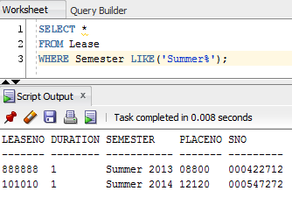

## (f)

Display the details of apartment inspections where the property was found to be in an unsatisfactory condition. 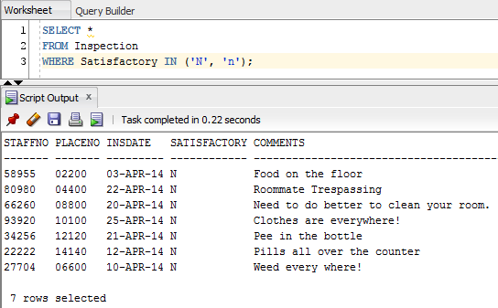

## (i)

Display the total number of students in each student category. 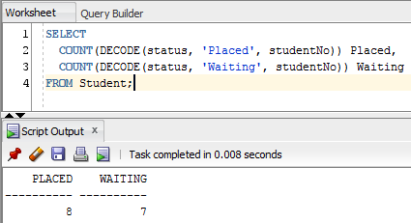

## (l)

Display the minimum, maximum, and average monthly rent for rooms in residence halls.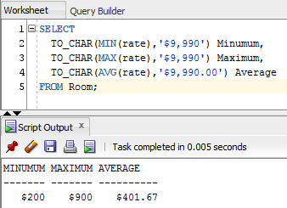

## (n)

Display the staff number, name, age, and current location of all members of the residence staff who are over 60 years old today.